In the HANA Development perspective

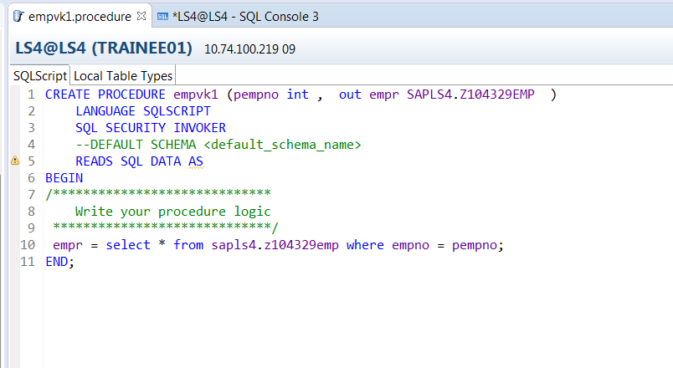

In the Modeler perspective.

